COMBONI JPIC NETWORK
The News Service of the Comboni Missionaries
North American Province

JPICN

July 2012 – Vol. 2. No. 7.

At the U.N., all eyes are focused on the long-awaited negotiations of the Arms Trade Treaty. In Sudan, there’s great concern for the people of the Nuba Mountains that reminds us of M.L. King’s quote: “We will have to repent in this generation not merely for the hateful words and actions of the bad people, but for the appalling silence of the good people.”
Selected Global News
The same applies to the people of Eastern Congo as relations between DRC and Rwanda quickly deteriorate.

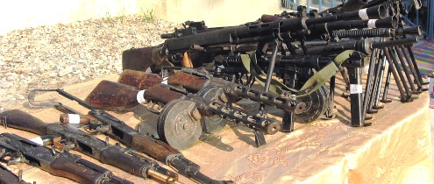One Shot at a Bulletproof Arms Trade Treaty (ATT): Will it Hit its Target? Since the early 1990s, an active civil society has promoted the negotiation of a comprehensive, legally-binding treaty “to establish standards and restrictions on the international trade in conventional arms.” The month-long United Nations Conference on the Arms Trade Treaty (ATT), chaired by Ambassador Roberto Garcia Moritán, begins at the U.N. (New York) on July 2 and will review the much-labored Chairman’s Draft Paper based on the four preceding Preparatory Committee meetings. Many of the positions endorsed by the Control Arms Coalition have been upheld. The Treaty must: (1) Stop the transfer of arms or ammunition where there is a substantial risk that they’ll be used in violation of international human rights; (2) Include all conventional arms including their parts and ammunition, all transfers and all transactions; and (3) Be transparent, effective and have a monitoring mechanism. Visit www.un.org/disarmament/convarms/ATTPrepCom.
Virtual Connections and More: ♦ Watch U.N. web TV here; ♦ Follow the Reaching Critical Will blog here;
♦ Join Facebook; ♦ New to the ATT? Click here; ♦ Get Africa Europe Faith & Justice Network’s insights on why we need a robust ATT here and in the June newsletter, here; and for ♦ Pax Christi’s Swallowing the Bullet: An Ethical Approach to an Arms Trade Treaty, with prayers and a letter to adapt, click here.

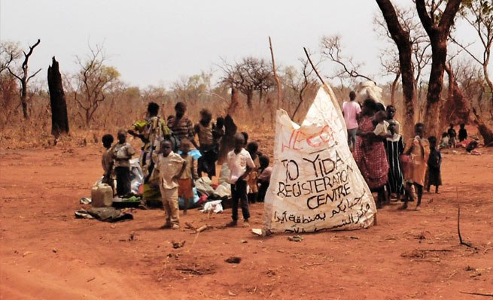The Ruthless Ambitions of the Khartoum Regime. Nearly a million Nuba people of Southern Kordofan, Sudan, whose homes are part of Sudan, but border South Sudan, are once again isolated—trapped in the middle of two wars. One has unfolded horrifically in the last year; the other is all about oil. The Nuba and the Sudan People’s Liberation Movement-Northern Sector (SPLM-N) are forever “branded” for rejecting Khartoum’s centralizing and Islamizing policies. They’ve fled to the caves on the mountain slopes to survive indiscriminate airstrikes of their villages, schools, churches and markets. This month, 400 exhausted and dehydrated refugees, mainly women and children, reached the camp of Yida in the South. Humanitarian assistance has been blocked despite the tripartite proposal by the U.N., the African Union and League of Arab States. An internationally led relief operation, accepted by both sides, is the only possibility to meet the needs of the estimated 420,000 Nuba people who are now internally and externally displaced. Learn more and take action:
♦ Pressure the U.N. Security Council to protect civilians in Sudan and take urgent action;
♦ Donate to the Comboni Missionaries here, or to the Nuba Emergency Campaign (IT & EN);
♦ Watch videos about the emergency here, and, in Italian, here, and an interview with Comboni Fr. Kizito Sesana on Italian TV here. Also, for a video on the situation of the refugees in Yida refugee camp, click here. Get additional information from Fr. Kizito’s blogsite.
♦ Download the report, We Can Run Away from Bombs but Not from Hunger, here. Read Eric Reeves’ article, Nuba Mountains’ Genocide: One Year Later, here, and Nicholas Kristof’s New York Times article, If Only Our Leaders had Mariam’s Guts, here.

Rwanda/Congo Relations deteriorate. Rwandan President Paul Kagame has called on neighboring Congo to take responsibility for a surge in rebel fighting rather than blame Kigali (Rwanda) for stoking the violence, marking a sharp escalation in rhetoric between the former foes. Read the article, When Lying is used as a Weapon of War, here, and get up-to-date perspectives (multilingual) from the Peace for Congo Network, here, and an aid worker's diary. Watch “I AM CONGO.” Read about how the U.S. is re-evaluating its policy towards Kigali here as well as the controversial U.N. Security Report, here.

♦ Nominate Victoire Ingabire for the Sakharov Prize of the European Parliament. She led the Rwandese opposition and the people in defying Paul Kagame’s absolute power. To sign, click here.
Take Actions
♦ Stop Violence in Mexico: Sign the petition to President Obama here, or here, to curb gun smuggling between the U.S. and Mexico. There have been 60,000 deaths in six years attributed to brutal violence. The Movement for Peace with Justice and Dignity (MPJD) and the Latin America Working Group have organized a peace caravan to travel the U.S. this summer. It will allow victims’ families to share their stories and includes a powerful photo exhibit,
A Farewell to Arms: Contraband on the Border. The message is “reduce the demand for drugs, stop the flow of arms and money south, and take the military off Mexico’s streets.” Read more, and learn about Javier Sicilia.
U.N. News & Others Events
U.N. Observance Days for July are
listed here.
The Permanent Missions to the United Nations “Bluebook” Directory provides contact information for the Missions and Staff of all member countries here.
♦ Highlights from Rio+ 20: (1) The final Rio 20+ document, “The Future We Want,” is particularly weak on commitments, corporate accountability, food security and women’s rights but, in the end, stronger on human rights. Official languages here; (2) Read the Women’s Major Group’s release, “Rio+20: Women Disappointed and Outraged” here; (3) Get conclusions of the Northern Alliance for Sustainability and follow-up on food security here.
♦ July 7, 2012: International Day of Cooperatives. This year’s theme encourages the growth and establishment of cooperatives all over the world, and recognizes their actions in helping to achieve the Millennium Development Goals. Click for U.N. site, and to learn more. For Spanish, click here, and for French, here.
♦ July 11, 2012: World Population Day marks the significance of population trends and related issues and is a day to think about how, where and why the world population is growing. Click here. For Spanish, click here, and for French, click here. A plethora of resources includes: (1) The United Nations Population Fund (UNFPA) (multi-language) here; (2) International Conference on Population and Development (2014), click here, and here; (3) Greening the Blue activities, here; and (4) Learn about and join the global movement, 7 Billion Actions, here.
Resources

♦ Africa Europe Faith and Justice Network (AEFJN) Factsheets on Land Grabbing, Economic Partnership Agreements, Access to Quality Medicines, Natural Resources, Small Arms and Light Weapons and Climate Change are now available. See www.aefjn.org/index.php/factsheets.html. Also in French.
♦ PASSOS Education and Training Center provides anti-violence and HIV prevention training, guidance and research for drug addicts and marginalized individuals in 12 communities of San Salvador, El Salvador. The group will be honored for its innovative work in September by the Washington Office on Latin America. Click here. ES too.
♦ Voices of our World are weekly public affairs radio programs sponsored by Maryknoll. They feature shows on social justice, peace projects, environmental concerns and other critical issues. Listen to podcasts here.
JPIC Combonline

♦ Congratulations to Sr. Azezet Kidane, a Comboni Missionary Sister based in Israel, who was honored as one of the “Heroes Acting to End Modern Day Slavery” by the U.S. State Department (Trafficking in Persons Report). For more.
♦ Magazine Editors change in Asia and South Africa. Fr. José Rebelo leaves the post of editor of World Mission (Manila, Philippines, click here) for that of Worldwide (Silverton, South Africa, click here), while Fr. David Domingues assumes the editorship of World Mission.
♦ Frs. Manuel Baeza and John Converset (NAP) were members of the VIVAT delegation at Rio’s U.N. Conference on Sustainable Development (40,000 attended), and also attended The People’s Summit and Comboni Forum in June.
1318 Nagel Road ♦ Cincinnati, OH 45255-3120 ♦ (513) 474-4997 ♦ FAX: (513) 474-0382
♦ To receive this newsletter, email combonipn@combonimissionaries.org; for all back issues, click here.
♦ Web site: www.combonimissionaries.org; related articles at www.jpic-jp.org/en.php.

Comboni Press Network (CPN) newsletter provides access to information on global issues from Church and Mission-related sources. Our focus is on Justice and Peace issues, and on how the U.S. policies affect the Third World countries. Please share your suggestions and ideas with us—we’re only an e-mail or fax away!

