NAP
Immigration issues in the USA and the World

The USA has at least 12 million undocumented immigrants living within its borders. They come from all parts of the world, but the largest number are from Latin America. Most have escaped from desperate circumstances, such as war other forms of violence or scarcity of resources and jobs.

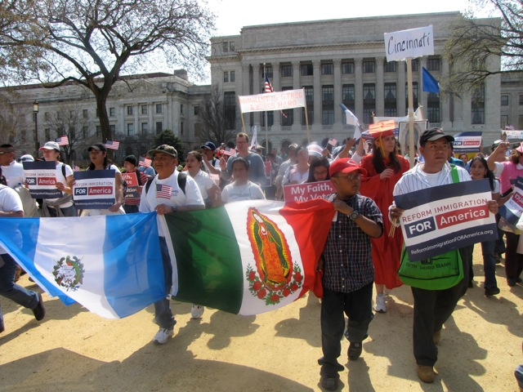
Among many US citizens there is open hostility and discrimination towards immigrants “of color”, especially the undocumented.

Although the country benefits from their hard work and family values, many politicians are unwilling to consider “comprehensive immigration reform” out of fear of the right-wing minority.

The Comboni Missionaries assist the immigrants directly by welcoming them into parishes, celebrating their cultures, using their languages, and also advocating for immigration reform in their local communities, as well as at the national level.

At the United Nations, through VIVAT International, we have also intervened with regard to the separation of parents and children through the review of the USA in the second round of the Universal Periodic Review.

