MISSION ANIMATION IN KENYA
KENYA

FOUNDATION
Jesus did not just entrust his mission to the apostles but to all those who would accept his message. All his followers are his missionaries (Luke 10, 1).He gives instruction (formation) and as Comboni Missionaries we are mandated to create awareness of what Jesus calls each baptised to do.
Three Ways in Which the Laity are called to fulfil their Missionary Vocation:
- Prayer: The harvest is rich but labourers are few, therefore pray the Lord of the harvest to send out labourers into his harvest (Luke 10, 2). Example: St. Teresa of the Child Jesus
- Charity (service) in one’s own community (local Church) – active participation in one’s own community according to the gifts from the Lord(1 Cor. 12).
- Once you receive the Good News brought to you by someone through the command of Jesus (Mathew 28, 19), remember that there is one who has not yet received it. It becomes now your responsibility to make it reach them:
- Go by yourself or
- Facilitate others
VISION
- Fostering a Missionary Spirit in the Local Church
- Inviting Local collaborators to Join the Work of Comboni Missionaries as Lay Missionaries, Friends of Comboni or Benefactors.

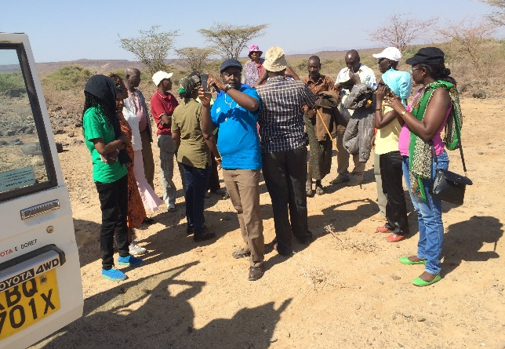
Registration desk during the meeting of Comboni friends
Taste of Mission: Comboni Friends visiting our Mission of Lokichar where they have started some small projects

